In our tradition we think of the Holy Spirit as a dove. When Jesus was baptized and came out of the water, the Holy Spirit settled on him as a dove. We think of the Holy Spirit as bringing peace and we associate doves with peace. But the Holy Spirit doesn’t take on just one or two traits. In this lesson the Holy Spirit comes like the rush of violent wind and with fire. That’s not a peaceful image in the sense that we often think of peace. That’s an image of action, of stirring up, of power, of change. The Holy Spirit that descended on that day filled the followers with the Spirit they needed to change the world.
To understand a little more about the change the Holy Spirit was bringing, we need to understand a bit about what Pentecost means in Judaism, because, of course, all Jesus’s followers in that room were Jews. Pentecost in Judaism is the holiday also known as the Feast of Weeks. The holiday has agricultural significance as well as spiritual significance. The spiritual significance is that it commemorates the law being given to Moses on Mount Sinai – basically the giving of the Ten Commandments and other laws. Jewish tradition says that at the giving of the law on Sinai a great flame appeared from heaven and divided into 70 parts so that each person heard the giving of the law in their own language.
Luke, then, the author of Acts, uses this image for the coming of the Holy Spirit on this occasion – to 120 Jewish followers of Christ from all over the world. The Holy Spirit coming is epoch-making, God’s new revelation to God’s people. It’s come to signal a difference between the Jewish commitment to God and the Christian’s commitment to God. The Jewish commitment is centered and directed by Torah (or the Law). The Christian commitment is centered around Jesus. It is centered around what Jesus did for us; what Jesus demonstrated for us; what Jesus gave us – grace—when we couldn’t keep the law. The Holy Spirit also came to bring power to the disciples that were there – and to us as disciples here and now -- to proclaim this epoch-making revelation to all the world.
When we let ourselves feel the power of this Spirit, we become active in ministry in ways even beyond what we have done before. We show and embody grace – the concept of forgiveness and love. We become incredibly creative in thinking of ways to tell and show others who Jesus was and what He gave us. We are open even though these ways of sharing the Gospel may be new and different because we realize that the news we have to share is life changing and, if enough folks allow it to change their lives, world changing. In fact it is this urgent sense of being on fire, of being electrified and open to sharing the Gospel in ways traditional and outrageous that actually brings the peace of God we so crave. When we all know who Jesus was, live like Jesus did, and accept His grace for us and for all people, peace on earth has come.
Joan Chittister describes this state in a poem she wrote for Pentecost that appeared in 2011. It reads in part:

May the Gifts of the Holy Spirit
bring fire to the earth
so that the presence of God
may be seen
in a new light,
in new places,
in new ways.

May our own hearts
burst into flame
so that no obstacle,
no matter how great,
ever obstructs the message
of the God within each of us.

May we come to trust
the Word of God in our heart,
to speak it with courage,
to follow it faithfully
and to fan it to flame in others.

When we let the Holy Spirit come into us, nothing can stop us from changing the world into a place of love and grace – nothing can stop us from sharing God.
Our Celtic Christian brothers and sisters have a different image of the Holy Spirit. Instead of thinking of the Holy Spirit as a dove, they think of it as a wild goose. That’s more appropriate for this context of the Holy Spirit’s coming. Wild geese come noisily. They are erratic and sometimes forceful, divebombing, and sometimes chasing their prey. They can be passionate and unsettling. You can’t miss them. That’s how the Holy Spirit came to those followers of Jesus. That’s how the Holy Spirit comes to stir us up, to get us out of our comfort zone and to prod us to do whatever we need to do to share the Gospel.
Behind me today is artwork done by the Rev. Hilary Ann Golden, a Methodist minister. It depicts a wild goose as the Spirit of Pentecost. It depicts that passionate creature that prods and pushes us into bold directions.
Spread the Gospel. Boldly. Passionately. Change the world.
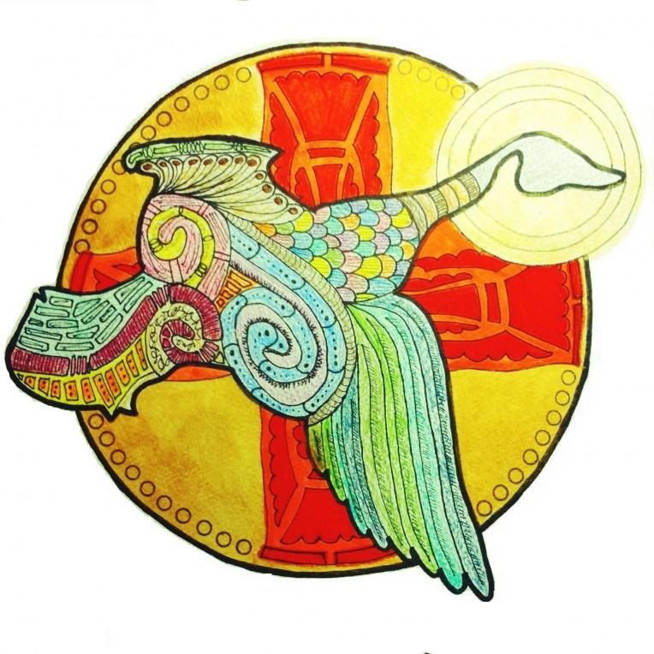
“The Wild Goose,” © 2013 Hilary Ann Golden

Hughes, R. K. (1996). Acts: the church afire (pp. 30–31). Wheaton, IL: Crossway Books.
Sister Joan Chittister, OSB, Huffington Post, June 10, 2011, https://www.huffpost.com/entry/pentecost-prayer_b_872130
Image copyright Hilary Ann Golden, used by permission. Found at https://www.asacredjourney.net/chasing-the-wild-goose/

